AP Calc AB Name: _______________

______________ _____________

WS Assessment

Target 14:

Optimization problems

Implicit relations

**I can:**

* Calculate minimum and maximum values in applied context or analysis of functions
* Interpret min/max values calculated in applied contexts
* Determine critical points of implicit relations

Unit 5: Analytical Applications of Differentiation

HW Target 14

Unit 5 Progress Check FRQ A and B

**Optimization**

Historically, optimization problems were among the earliest applications of what we know now call differential calculus.

*Notes: With today's graphing technology, one can find extrema without calculus, but for learning purpose you should use both algebraic and graphical methods in this lesson. (Applying first derivative and second derivative test on the function)*

Find two numbers whose sum is 20 and whose product is as large as possible.

Find two positive numbers whose product is 185 and the sum is a minimum.

Which points on the graph of  y = 4 – x2  are closest to the point (0, 2)?

Four feet of wire is to be used to form a square and a circle. How much of the wire should be used for the square and how much should be used for the circle to enclose the maximum total area?

We need to enclose a field with a fence. We have 500 feet of fencing material and a building is on one side of the field and so won’t need any fencing. Determine the dimensions of the field that will enclose the largest area.

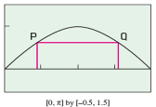Inscribing Rectangles. A rectangle is to be inscribed under one arch of the sine curve. What is the largest area the rectangles can have, and what dimensions give that area? Hint: P = (x, sin(x))

A cone of height h and radius r is constructed from a flat, circular disk of radius 4 in. by removing a sector out of the circle then connecting the edges. What arc length x will produce the cone of maximum volume. Hint: Prove r = 4 – .5x/pi

We want to construct a box whose base length is 3 times the base width. The material used to build the top and bottom cost $10/ft2 and the material used to build the sides cost $6/ft2. If the box must have a volume of 50ft3 determine the dimensions that will minimize the cost to build the box, and what is that cost? Ans: $637.60

We want to construct a box with a square base and we only have 10 m2 of material to use in construction of the box. Assuming that all the material is used in the construction process determine the maximum volume that the box can have.

Design a one-liter oil can shape like a right circular cylinder. What dimensions will use the least material? (1 liter = 1000 cm3)

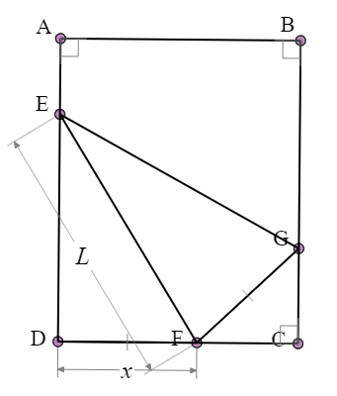A rectangular sheet of 8.5x11 in. paper is placed on a flat surface. One of the corners is placed on the opposite longer edge, as shown in the figure, and held there as the paper is smoothed flat.

The problem is to make the length of the crease as small as possible i.e find x so that L get minimum

Hint: Show $L^{2}=\frac{2x^{3}}{2x-8.5}$

Find the squared base box (without a top) with least surface area for a fixed volume.

Alternative way to solve this problem is by using implicit differentiation.

Set V = x2y, A = x2 + 4xy The goal is to find the minimum value of A while holding V constant.



Print

Find the point where slope of the tangent line of the curve the curve $x^{\frac{2}{3}}+y^{\frac{2}{3}}=9$  is horizontal?

Find the point where slope of the tangent line of the curve the curve $y2^{y}=x$  is vertical ?

Given the curve $\frac{x^{2}}{16}+\frac{y^{2}}{9}=1$. Show that this curve is concave up in quadrant IV

The curve defined by x2y = 4. Describe the behavior of the curve at point (2,1)? Direction and concavity

Given the curve $x^{2}y+\frac{x^{2}}{y}=5$. Is it increase or decrease at point (1,.201639)?

Find dy/dx if (x2 + y2)2 = 10xy

The curve defined by (x2 + y2)2 = 10xy. Describe the behavior of the curve at point (1,1.80109)? Direction and concavity

Given f(x) = x+ sin(x) for 0 ≤ x ≤ 2π, find all points of inflection of f.

Assessment

Find the point where slope of the tangent line of the curve the curve $x^{\frac{2}{5}}+y^{\frac{2}{5}}=1$  is horizontal?

Find the point where slope of the tangent line of the curve the curve $sin(y)=e^{x}$  is vertical ?

Given the curve $\frac{x^{2}}{16}-\frac{y^{2}}{9}=1$. Show that this curve is concave down in quadrant I

At what value(s) of x does the tangent to the curve x2 + y2 = 36 have a slope of –1.

Find the shortest distance between the point (1, 0) and the curve y =x3.

Of all rectangles of area 100, which has the smallest perimeter?